Part- 3 Chapter- 11
Aplia Homework: Managing Aggregate Demand: Fiscal Policy

1. The multiplier effect
Consider a hypothetical economy where there are no taxes and no international trade. Households spend $0.60 of each additional dollar they earn and save the remaining $0.40. If there are no taxes and no international trade, the oversimplified multiplier for this economy is 2.5.

Suppose investment spending in this economy increases by $250 billion. The increase in investment will lead to an increase in income, generating an increase in consumption that increases income yet again, and so on.
Fill in the following table to show the impact of the change in investment spending on the first two rounds of consumption spending and, eventually, on total output and income.
Change in Investment Spending = $250 billion
First Change in Consumption = ____ billion
Second Change in Consumption = ____ billion
∙ ∙
∙ ∙
∙ ∙
Total Change in Output = ____ billion

Now consider a more realistic case. Specifically, assume that the government in our hypothetical economy collects income taxes. In this case, the multiplier will be ________ the oversimplified multiplier you found earlier.

Suppose that the price level in our economy remains the same and that there is still no international trade. Now, however, the government decides to implement an income tax of 5% on each dollar of income. The MPC and MPS, however, remain the same as before. In this case, after accounting for the impact of taxes, the multiplier in this economy is _______, and a $250 billion increase in investment spending will lead to a _______ billion ________ in output.

2. Automatic stabilizers
Consider the economies of Kimberlei and Clarkistan, which are identical except that the multiplier in Kimberlei is larger than that in Clarkistan.
This means that Kimberlei's GDP is ________ Clarkistan's GDP to fluctuations in the components of total spending.

Features of the economy that reduce its sensitivity to shocks are called automatic stabilizers.
Suppose again that the economies of Kimberlei and Clarkistan are identical except that Kimberlei has instituted a system of unemployment insurance, whereas Clarkistan hasn't.
Clarkistan's economy is _______ sensitive to fluctuations in GDP than Kimberlei's economy. This is because the system of unemployment insurance has ______ Kimberlei's multiplier.

3. Discretionary fiscal policy and multiplier effects
Consider a hypothetical closed economy in which the marginal propensity to consume (MPC) is 0.5 and taxes do not vary with income (that is, taxes are fixed rather than variable and the income tax rate t=0). The following graph shows the aggregate demand curves (AD1 and AD2), the short-run aggregate supply (AS) curve, and the long-run aggregate supply curve at the potential GDP level. The economy is currently at point A.
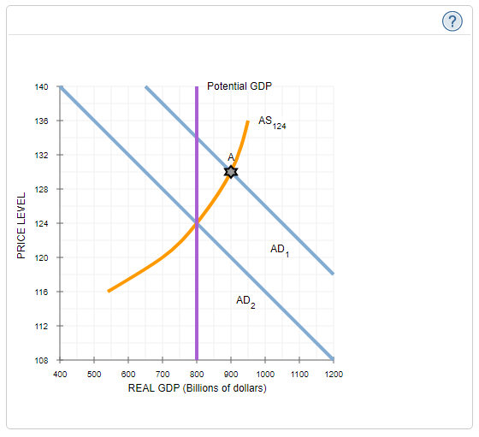

The economy is currently experiencing _______ gap of _______ billion.

To close this gap, one option would be for the government to _______ government purchases by _______ billion (assuming net taxes do not change).

If the government kept its purchases constant, it could also close the gap by _______ net taxes (taxes minus transfers) by _______ billion. (Hint: In this case, since taxes do not vary with income, the formula for the multiplier for a change in fixed taxes is −MPC1− MPC.)

4. Effects of discretionary fiscal policy
Suppose the economy had been producing at potential GDP but now is producing above it. Which of the following are discretionary fiscal policies that could bring the economy closer to potential GDP? Check all that apply.

A rise in spending to prevent coastal erosion
A tax increase
A reduction in spending on new road construction
A tax cut

5. Automatic stabilizers and discretionary fiscal policy
Suppose the government increases taxes to rein in consumer spending, but everything else in the economy remains constant.
On the following graph, shift the aggregate demand (AD) curve, the short-run aggregate supply (AS) curve, or both to show the intended short-run effect of this fiscal policy on the economy.
Note: Select and drag one or both of the curves to the desired position. Curves will snap into position, so if you try to move a curve and it snaps back to its original position, just drag it a little farther.

Because temporary tax changes ____________, they will be _______ effective as fiscal policy than anticipated.

6. Supply-side effects
Consider a fictional economy that is operating at its long-run equilibrium. The following graph shows the aggregate demand (AD) curve and short-run aggregate supply (AS) curve for the economy. The long-run aggregate supply curve is represented by a vertical line at the potential GDP level of $6 trillion. The economy is initially producing at potential GDP.
Suppose that fiscal authorities decide to increase marginal tax rates. Assume that this change in marginal tax rates is perceived as a long-term change.
Shift the appropriate curves to illustrate the supply-side view of the fiscal policy effect on output and the price level.
Note: Select and drag one or both of the curves to the desired position. Curves will snap into position, so if you try to move a curve and it snaps back to its original position, just drag it a little farther.

True or False: Supply-side economics is a long-run, growth-oriented strategy.
True
False

7. Graphical treatment of taxes and fiscal policy
The main difference between variable taxes and fixed taxes is that unlike variable taxes, fixed taxes _________.

The following graph shows the consumption schedule for an economy with a given level of taxes. Suppose the government implements a tax increase through a variable tax.
Use two green points (triangle symbol) to connect the two black points (plus symbols) representing the consumption schedule after the change in taxes.
Hint: The new consumption schedule must pass through one point on the left and one point on the right.

The blue line on the next graph represents the original total expenditure line for this economy before the change in tax structure.
Use the new consumption line you just plotted to calculate the new total expenditure at two levels of real GDP and fill in the following table.
GDP level | Total Expenditure
(Billions of dollars) | (Billions of dollars)
10 | ________
90 | ________

Use the green points (triangle symbols) to draw the new total expenditure line on this graph given the tax increase through a variable tax previously discussed and subsequent changes in the consumption schedule shown on the preceding graph.

Suppose that the government also considered a fixed tax hike and that the resulting consumption schedule would have also passed through one black point (plus symbols) on the left and one black point on the right on the first graph (though not necessarily the same points as the consumption schedule resulting from the tax increase through a variable tax).
On the first graph, use two purple points (diamond symbol) to connect the two black points (plus symbols) representing the consumption schedule that would result from a tax increase through a fixed tax. (Hint: As before, the consumption schedule must pass through one point on the left and one point on the right.)
On the second graph, use the purple points (diamond symbols) to draw the total expenditure line that would result from a tax increase through a fixed tax indicated on the top graph.
True or False: The change in equilibrium output is smaller when the government implements the fixed tax hike.

True
False

8. Algebraic treatment of taxes and fiscal policy
Consider a small country that is closed to trade, so its net exports are equal to zero. The following equations describe the economy of this country in billions of dollars, where Y is real GDP, C is consumption, DI is disposable income, I is investment, and G is government purchases:
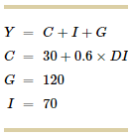
Assume that this economy initially has a fixed tax and that net taxes (taxes minus transfer payments) are $100 billion. Disposable income is then (Y−100). Aggregate output demanded is ________.

Suppose the government decides to increase spending by $10 billion without raising taxes. Because the expenditure multiplier is ________, this will increase the economy's aggregate output demanded by ________.

Now suppose that the government switches to an income tax, which is a type of variable tax, of 25%. Because consumers retain only 75% of each additional dollar of income, disposable income is now 0.75×Y. In this case, the economy's aggregate output demanded is ________.

Given an income tax of 25%, the expenditure multiplier is approximately _______. Therefore, if the government decides to increase spending by $10 billion without raising tax rates, this would increase the economy's aggregate output demanded by approximately ________.

A $10 billion increase in government purchases will have a larger effect on output under a __________.

